Scouts and Shovels: “Crashing the Gates” with Bertha Dutton Student Handout

Vocabulary

Archeology: the study of people within the past
Artifact: an object made and used by people within the past
Context: where an object was found in the ground including depth and surrounding objects
Ethnography: scientific study of people and culture, especially through direct observation
Feature: as opposed to portable artifacts, these are the non-portable parts of an archeological site such as walls, hearths, or trash pits

Introduction: “Women’s Work” in the 19th and 20th Centuries

In 19th- and 20th-century America, gender ideologies governed women’s employment opportunities. Once married, women were supposed to stay home to care for their families while their husbands worked. It was mostly single women therefore who entered the workforce. There, the concepts of “women’s work” and “men’s work” defined the few jobs that were ‘acceptable’ for them to perform. Women were viewed as “too delicate and small for many jobs.” They often became teachers, nurses, or secretaries or worked on a factory assembly line. However, once they married or became pregnant they were often required to quit their jobs. In fact, marriage bar laws enforced from the 1800’s to the 1950’s within certain firms and school boards prevented employers from hiring married women at all. Starting in the mid-19th century, before they even had the right to vote, women started to challenge these ideologies and enter traditionally male-dominated fields.

Women in Archeology
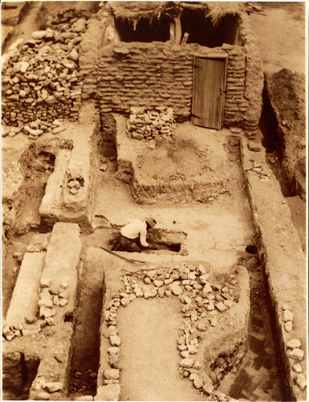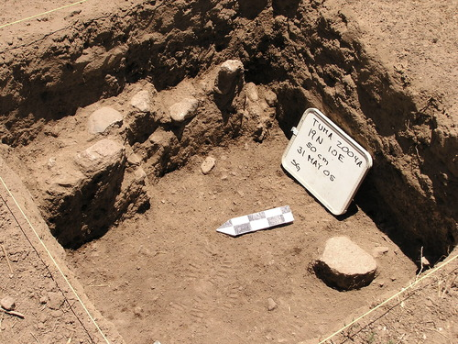
Tumacácori National Historical Park, 1935 (left) and 2005 (right) excavations. National Park Service.
Archeology is the study of material culture, such as objects and buildings, to know how people of the past lived. Archeologists divide their time between excavating historic sites, analyzing artifacts in the laboratory, and writing interpretations of their finds. Excavations require long hours spent outdoors performing manual labor. Because of this fact, archeology was traditionally viewed as a “men’s field” and unsuitable for “delicate” women.
Around 1900, women started to “crash the gates” of archeology. At that time, many excavations were carried out in cooperation with the National Park Service. Hearing that “the best way to get into the Park Service is to marry a Ranger,” several of the early NPS women did just that and labored alongside their husbands to preserve park resources as Rangers and archeologists. Some women, like Sallie Pierce Brewer, were referred to as “Honorary Custodians Without Pay.” This meant that even though they and their husbands performed the same work, the wives were not considered NPS employees and did not receive a salary. These women and other early female archeologists helped preserve thousands of archeological resources. However, their work often became overshadowed by that of their well-known husbands. As paid employees, these men were often the ones who led the excavations and whose names were atop the published reports. These factors meant that they, rather than their wives, became the public face of the excavations.

Bertha Dutton
Bertha Dutton. (Morris, Elizabeth Ann and Caroline B. Olin. “Obituary: Bertha Pauline Dutton (1903-1994).” In American Antiquity, vol. 6, no. 4, 1997, 652.)
Bertha Dutton (1903-1994) was one of these early female archeologists. Between 1929 and 1931, she attended the Lincoln Nebraska School of Commerce and the University of Nebraska to study history and philosophy. Her life completely changed when she was hit by a car and ended up in the hospital. During this time, she was visited by one of her professors who suggested that, given her interest in history, she should enroll in one of Edgar Hewett’s archeology field school courses at Chaco Culture National Historic Park run through the University of New Mexico. Bertha took the advice.

Hewett was controversial for his time because he allowed, even encouraged, women to attend the field school alongside men. For fifteen seasons between 1929 and 1942, and again in 1947, he taught his students excavation methods and artifact analysis at Chaco. Students lived in tents or hogans (traditional Navajo log structures), were given one gallon of water a day for washing clothes and taking bucket baths, and were dependent on supplies driven in from 100 miles away. Their time was spent excavating the ancient ruins, processing artifacts, visiting the nearby trading post, and attending Navajo ceremonies. Bertha was among the many female archeologists who began their careers at Chaco.
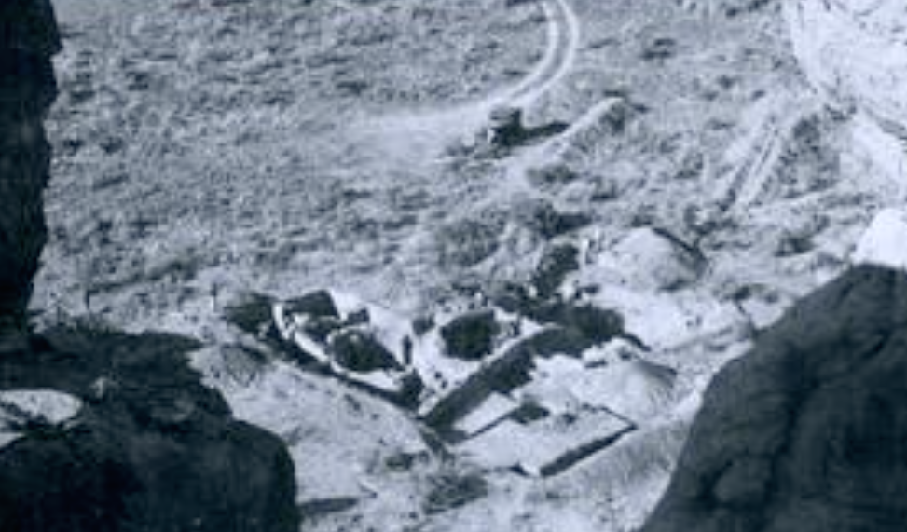
Bertha’s in-progress excavation at Leyit Kin in Chaco Canyon. November 1936. Collection number 87832, 0018/001. Photograph by Erik Reed. Chaco Culture NHP Museum Collection, Museum of New Mexico.
Bertha was a student at the University of New Mexico between 1933 and 1936. During that time, she worked as a secretary in the Anthropology department. She graduated in 1937 with a Master’s degree, using the Leyit Kit site at Chaco for her thesis topic. She later received a PhD in 1952 from Columbia University. From 1939 to 1965, she worked at the Museum of New Mexico, starting as the Curator of Ethnology and eventually becoming the Head of the Research Division. In 1963, she published her most famous work entitled Sun Father’s Way, a study of the murals at the Kuaua site in Coronade State Monument, New Mexico. After leaving this position, she taught for a year at St. Michael’s College in Santa Fe then worked from 1966 to 1975 as the director of the city’s Museum of Navajo Ceremonial Art. From 1973 to 1975, she served as the only female member of the National Park Service Advisory Committee. Throughout her career, she maintained close relationships with local Native American tribes and conducted many ethnographical studies.
In 1968, Bertha was invited by Lady Bird Johnson for a luncheon at the White House for “Women Doers.” In 1985, she received the Society for the American Archeology 50th Anniversary Award for Outstanding Contributions to American Archeology. In 1987, she was named a Santa Fe Living Treasure and the next year was featured with fellow archeologist Florence Hawley Ellis in the Arizona State Museum exhibit “Daughters of the Desert: Women Anthropologists and the Native American Southwest, 1880-1980.”

Bertha’s Methods: The Girl Scout Archeological Mobile Camp
Throughout her career, Bertha was dedicated to public education. While working at the Museum of New Mexico, she taught adult classes about cultural resources. She geared many of her publications, including her 1983 book American Indians of the Southwest, towards members of the public who wished to learn about ancient Native peoples.
However, her greatest project was the Girl Scout Archeological Mobile Camp. From 1947 to 1957, in partnership with the Girl Scouts of America, Bertha led senior Scouts from across the country on a two-week camping tour of archeological sites in the Southwest.
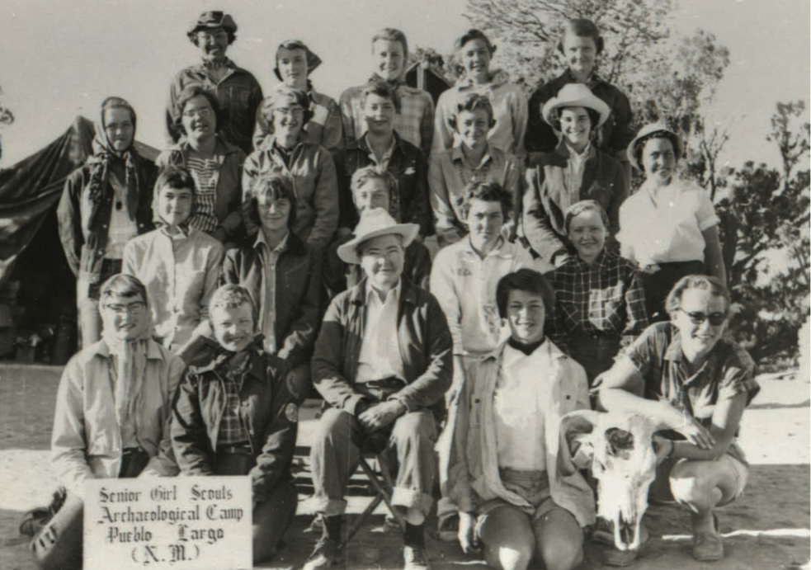
Senior Girl Scouts at Pueblo Largo. Bert is sitting front center. (Cohen, Leslie. “Dutton’s Dirty Diggers: ‘She Taught Us to Be Bold.’” In El Palacio, vol. 111, no. 2, Summer 2006, 35.)

Their route covered hundreds of miles and changed slightly every year. Jo Tice Bloom, a participant in 1948, remembers seeing the Kuaua ruins at the Coronado State Monument, Chetro Ketl and Pueblo Bonito at Chaco Canyon National Monument, Wupatki National Monument, and a Navajo summer camp among other sites. The girls also toured museums and attended lectures given by National Park Service staff, visiting scholars, and “Bert” herself on ancient lifestyles and artifacts. Though the girls did not excavate in the early years of the camp, they toured so many archeological sites and got so covered with desert road dust that they took to calling themselves “Dutton’s Dirty Diggers.” In the first year of the camp, the Scouts composed a song that became a favorite to sing while traveling in the trucks along the desert roads and sitting around the campfire:
From the pup tens down at Dutton’s to the place where Pueblos dwell
To the dear old mountain rocks we love so well—
Where the Diggers all assemble, with their tea cups raised on high
And the magic of our singing casts a spell,
Yes, the magic of our singing, of the songs we love so well,
“Tell me why”—“We are the Diggers”—and the rest.
We will serenade our Bert, while life and love they last,
Then we’ll pass and be forgotten with the rest.
We are poor little Diggers who have lost our potsherds
Boo-hoo-hoo!
We are poor little Scouts who’ve been led astray
Following Bert
Girl Scout songsters out on a spree
Digging to the end of eternity
Lord have mercy on such as we
Following Bert.
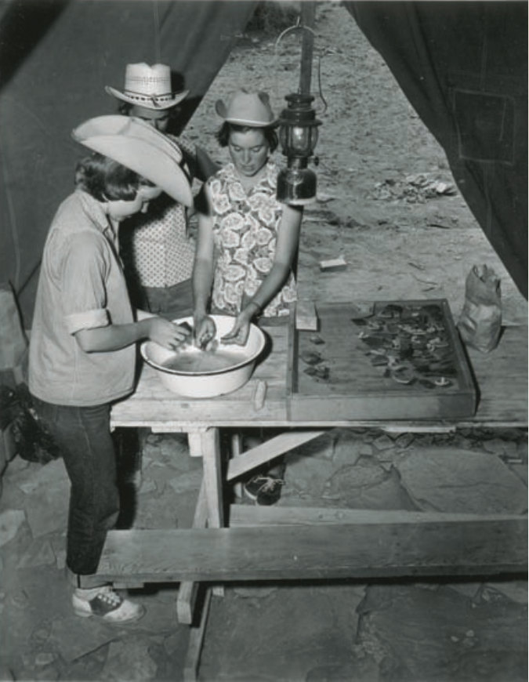
Scouts washing artifacts in the lab tent. (Cohen, Leslie. “Dutton’s Dirty Diggers: ‘She Taught Us to Be Bold.’” In El Palacio, vol. 111, no. 2, Summer 2006, 36.)

In 1951, following many of the girls’ requests, Bert turned the mobile camp into an archeological field school. For the next five seasons, Senior Scouts excavated at Pueblo Largo in the Galisteo Basin. Like at Bertha’s own field school in Chaco Canyon, the team lived in on-site tents, spent their time excavating the site, recording finds in field notebooks, and processing artifacts in the laboratory tent.
This field school was remarkable for multiple reasons. First, it was led by a female archeologist. As discussed above, archeology at that time was not viewed as a “woman’s field.” The few women who did become archeologists often were assigned to laboratory rather than field tasks and their work became overshadowed by that of their male counterparts. Bertha herself had lamented that in museums and historical societies often “men are in the top jobs and women are doing the work.” Through her unique position, Bertha became a role model and helped open the field for future female scholars within the field.
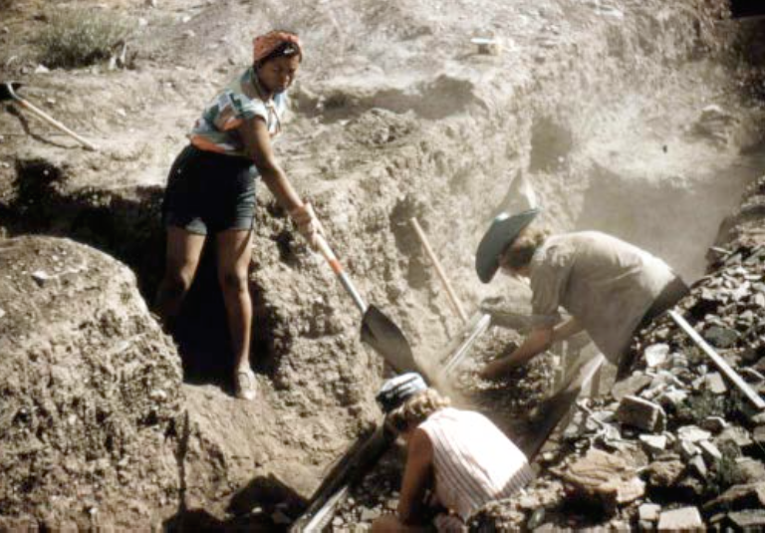
Scouts excavating at Pueblo Largo (LA183). Dutton Collection, MIAC/LOA, Cat. #G1-045, B. Bauer photo. Featured in Wilson Gordon P., Leslie Goodwill Cohen, Carole Gardner, and G. Stuart Patterson.
Second, Bertha’s field school offered a great opportunity for these young women. At that time, girls were expected to marry and stay at home caring for their families rather than go wield shovels and “travel the dusty and dangerous roads of the Southwest in vehicles of questionable reliability.” Together Bertha and her Scouts proved to anyone reading their stories in the newspaper that young women were not just interested in “glamour…dates, and lipstick.” They too could perform and even excel in the scientific field of archeology.
Third, Bertha taught these young women more than just archeological methods. She aimed to “encourage young women to pursue their own ambitions and not be satisfied simply with the expectations of others.” The field school was her way of showing these young women that no professional field, even if society considered it to be a “man’s job,” was out of their reach.

Activity: Archeological Museum Exhibit

Imagine that you are an archeologist working with Bert at Pueblo Largo and have found the following artifacts. She tasks you with creating a museum exhibit for them:
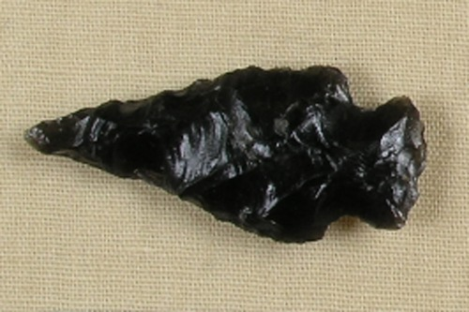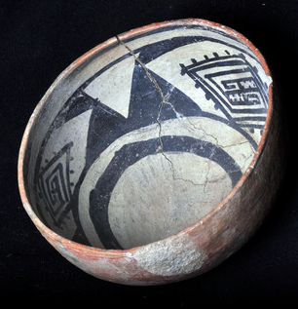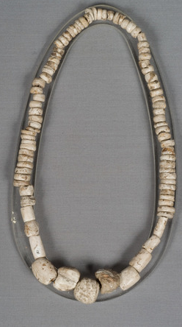
Archeological artifacts. National Park Service.

Step 1) For each object, write a paragraph for museum visitors describing the object in as much detail as you can. What do you want visitors to know about the artifact? What is it made out of? What was it used for? What can it tell you about ancient Native American life?

Step 2) Design and draw your museum case. How will you arrange these artifacts and your written interpretations? Is there anything you would want museum visitors to see first?

Step 3) Write an advertisement for your exhibit for the museum website. Include color and illustrations. How would you get people to come see your exhibit? What will they learn about?

Mandelson, Dayle A. “Women’s Changing Labor-Force Participation in the United States,” in Women and Work: A Handbook, eds. Paula J Dubeck and Kathryn Borman, 6.
Mandelson, Dayle, “Women’s Changing Labor-Force Participation,” 6.
Martelle Trager, as quoted in Kaufman, Polly Welts, Natural Parks and the Women’s Voice: A History, University of New Mexico Press, 1996, 87.
Ruth Ashton Nelson, as quoted in Natural Parks and the Women’s Voice: A History, 87.
Kaufman, Women’s Voice, 86.
Joiner, Carol. “The Boys and Girls of Summer: The University of New Mexico Archeological Field School in Chaco Canyon,” in Journal of Anthropological Research, vol. 48, no. 1. Spring 1992, 56; Kaufman, Polly Welts. National Parks and the Woman’s Voice: A History, University of New Mexico Press, 1996, 84.
Joiner, “Boys and Girls,” 52.
“The 1976 Women in New Mexico Exhibit: Bertha Dutton.” American Association of University Women-New Mexico. 1 January 1976; Morris and Olin, Obituary, 655.
Morris and Olin, Obituary, 655.
Morris and Olin, Obituary, 652.
Bloom, Jo Tice. “Dr. Bertha Dutton and Her Dirty Diggers.” In Sunshine and Shadows in New Mexico’s Past Volume 3: The Statehood Period, 1912-Present. Edited by Richard Melzer, Historical Society of New Mexico Centennial Series, 2012.
Dutton, Bertha P. “The Diggers Complete their Fifth Season of Senior Girl Scout Archeological Mobile Camps.” In El Palacio, vol. 58, no. 11, November 1951, 359.
Cohen, Leslie. “Dutton’s Dirty Diggers: ‘She Taught Us to Be Bold.’” In El Palacio, vol. 111, no. 2, Summer 2006), 36.
Leckie, Shirley A. and Nancy J. Parezo. “Introduction.” In Their Own Frontier: Women Intellectuals Re-Visioning the American West. Edited by Shirley A. Leckie and Nancy J. Parezo. University of Nebraska, 2008, 23.
Cohen, ‘She Taught Us to Be Bold,’ 36.
Cohen, ‘She Taught Us to Be Bold,’ 37.
Morris and Olin, Obituary, 655.

